**Staff Site**

**URL :** <http://integrateortho2.sourcefuse.com/staff/login/>

**Credentials :** testdoc/testdoc

1. **Dashboard**

Dashboard comprises of Basic Reports and total Cards Purchased. Staff User can also check weekly report by selecting “Week” from drop down button Under Basic Report.

**2. Level Up Promotions**

Level up Promotions are the Promotions set by the Admin. It allows to check Active Promotion Plans, Edit Promotion and create Level up Treatment plan.

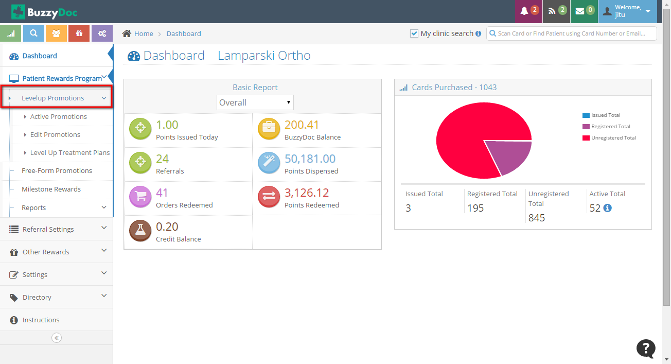

**Active Promotions**

Under Active Promotions all the Promotions which has been added under **“Global Promotions”** from Super Admin site are shown. From here Staff user can Activate/Deactivate the Promotions according to his clinics needs.

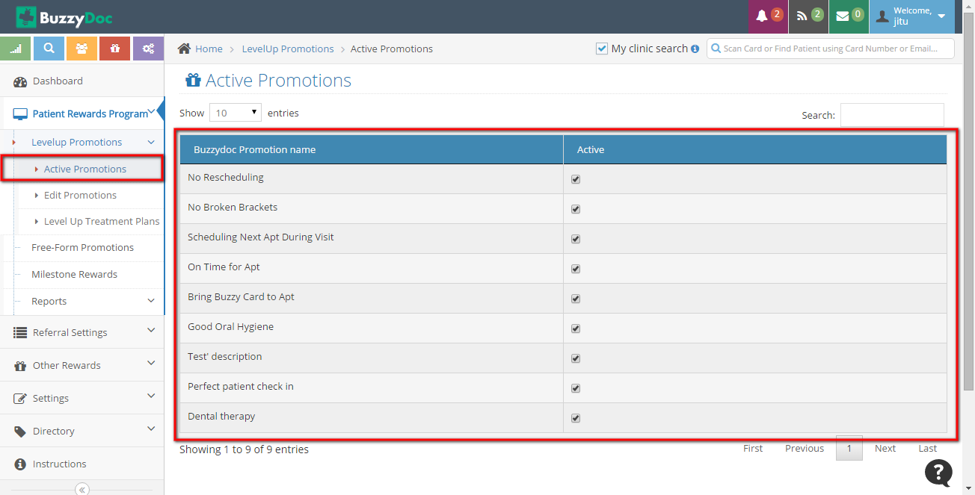

**Edit Promotions**

It allows to Edit the Active Promotions by Clicking Edit button corresponding to Promotion Display Name.

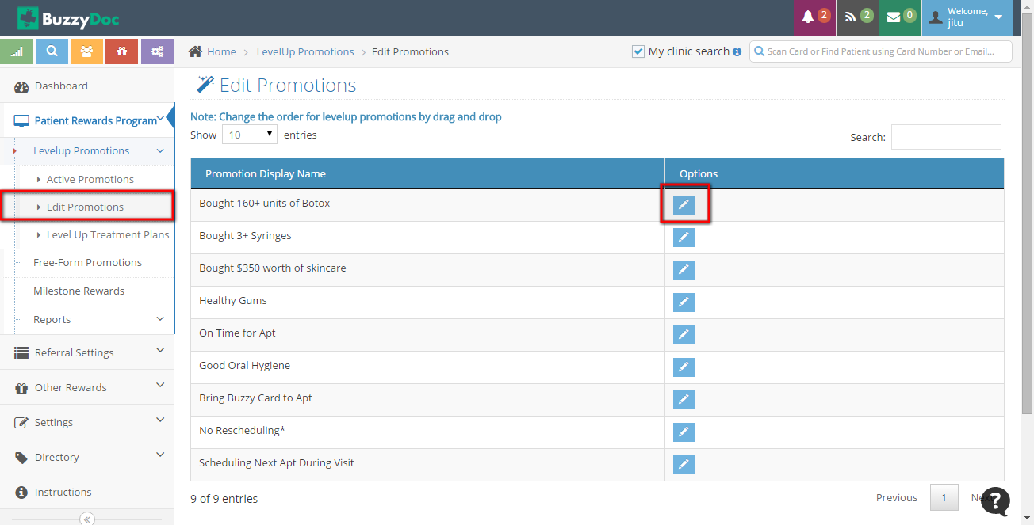

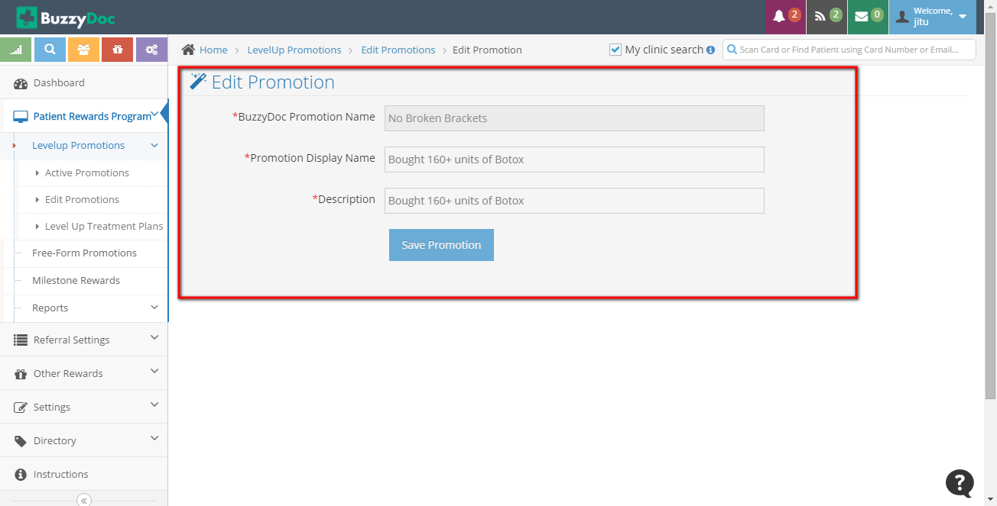

**Level Up Treatment Plans**

Treatment Plan allows to add and delete different plans in which Clinic deal in. On completing different stages of Treatment Plan, Patients might get some rewards based on Clinic.

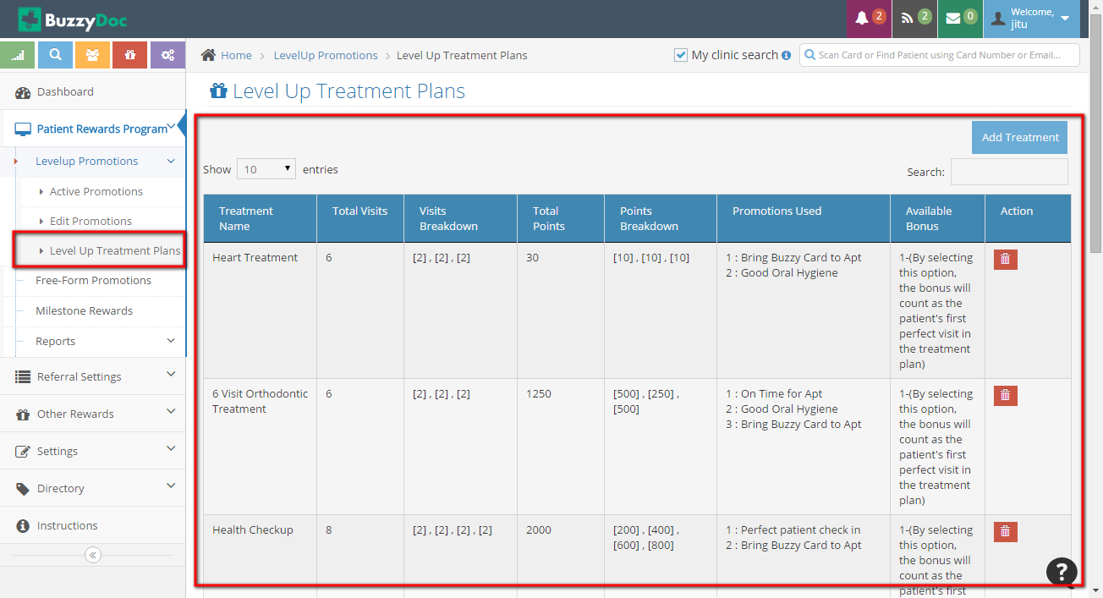

**Add Treatment**

Staff can Add Treatment by clicking Add Treatment button on Top Right corner. It allows to add new Treatment plan which is to be practised under that clinic.

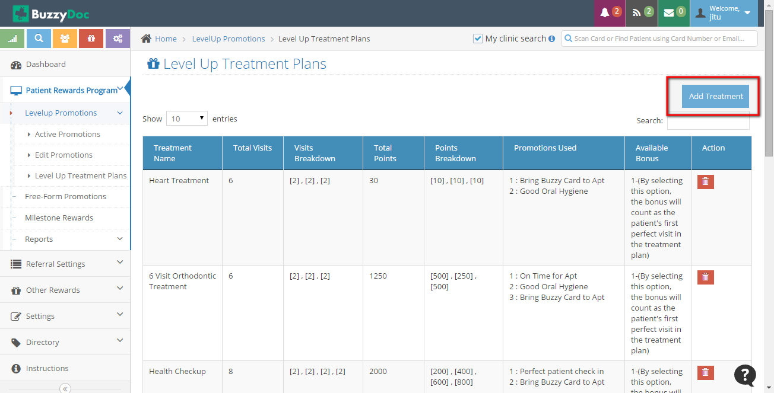

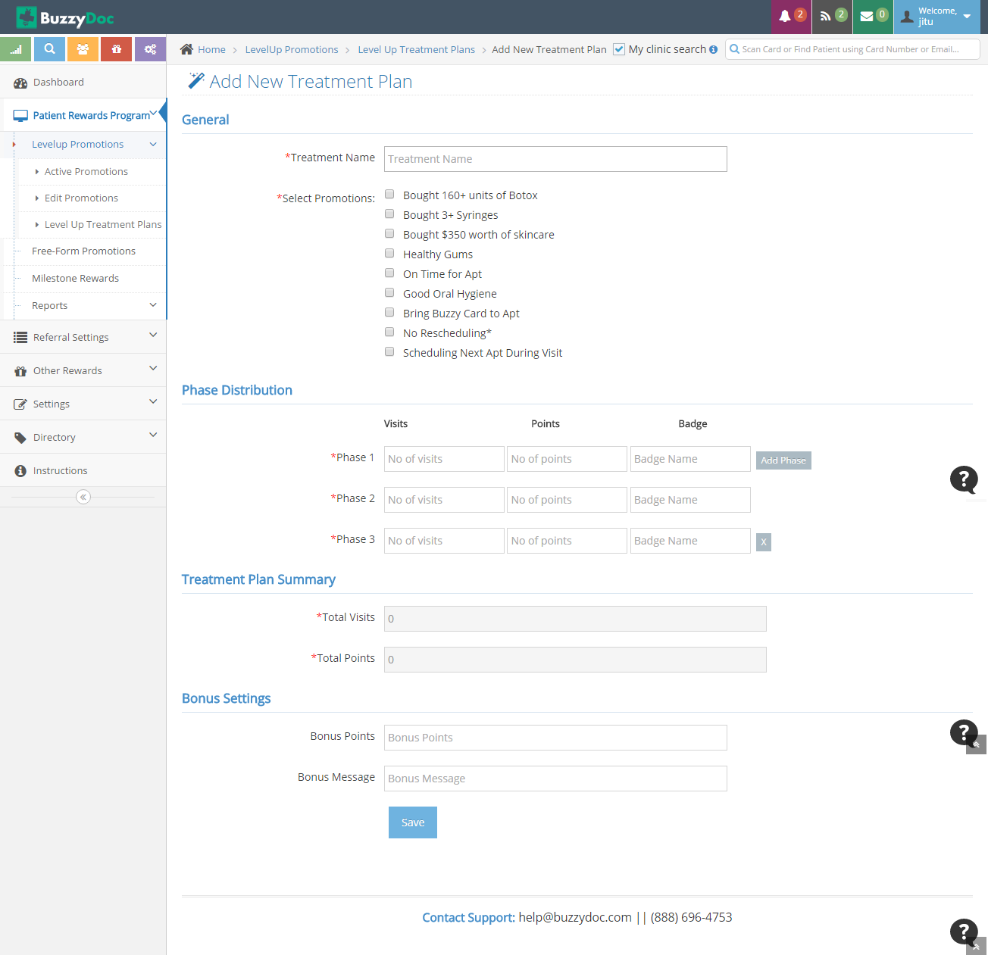

* **General**

Under General Staff User needs to define Treatment Name and Promotions to be awarded.

* **Phase Distribution**

Under Phase distribution Staff Member needs to define total number of Visits in each Phase, Points and Badge to be awarded after completion of each phase.

* **Treatment Plan Summary**

It summarises the total number of Visits and Points in a plan.

* **Bonus Setting**

It allows to give Bonus points to the patients on successfully completing the plan.

**Free Form Promotions**

Free Form Promotions are the promotions added by the clinics to reward to their patients other than Level up Promotions.

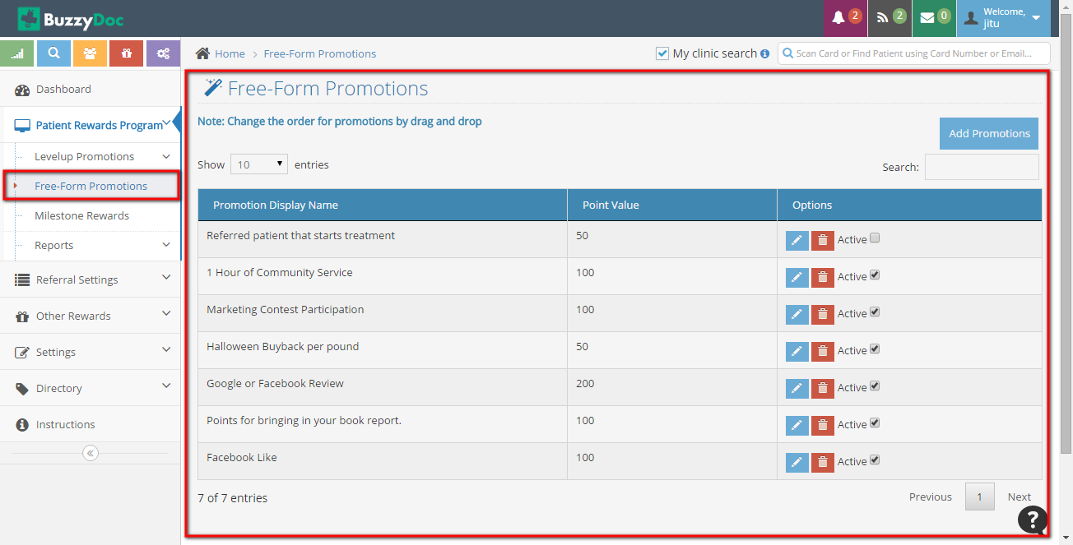

Free Form Promotions can be Add,Edited,Deleted,Activated/Deactivated

**Add Promotions**

Free Form Promotions can be added by clicking Add Promotions button on top-right corner

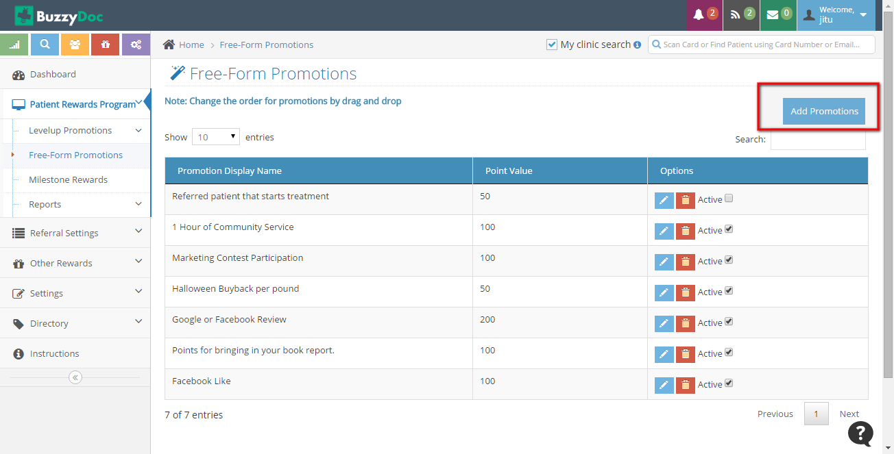

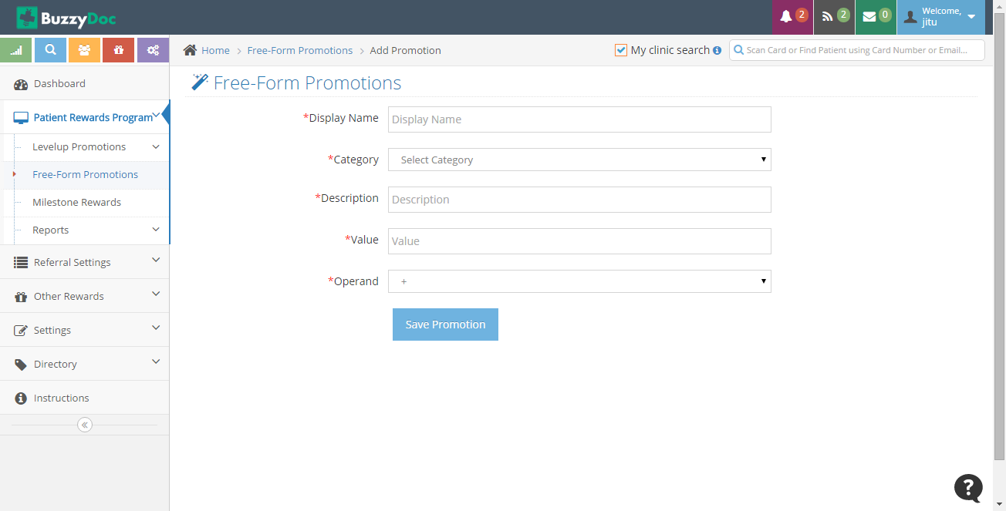

* **Display Name**

It allows to mention the name of the Promotion.

* **Category**

It allows to define the is it a promotion for Regular Visit or Bonus Point.

* **Description**

It allows to define the description of the promotions.

* **Value**

It allows to mention points to be given other than Level up promotion points

* **Operand**

It decides whether to sum up or multiply the points from the Level up promotion points.

**Milestones Rewards**

It defines the Milestones on attaining certain points and according to it User can redeem the coupons/product and services. Rewards can be added from “Manage Other Rewards”.

**Report**

Report allows to know how many Point has been Awarded or Redeemed for a particular period.

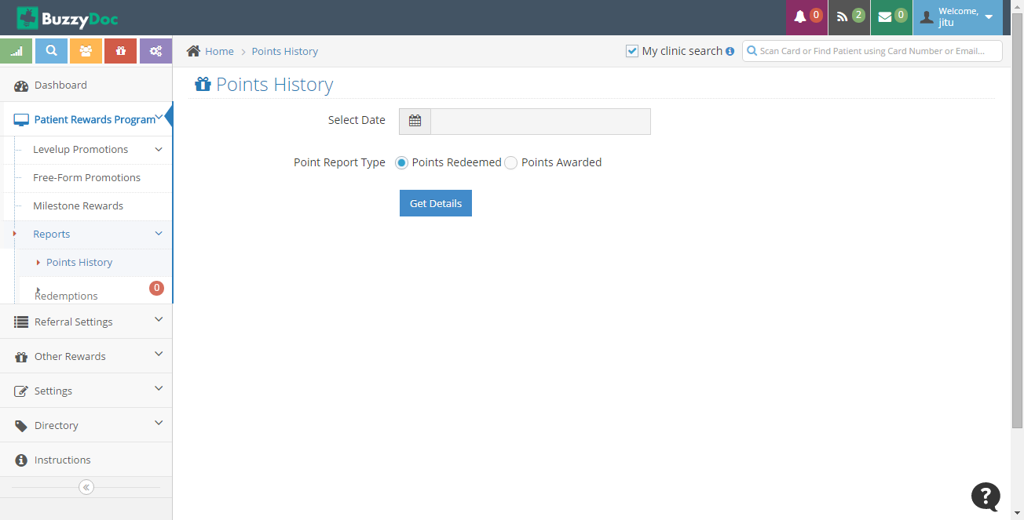

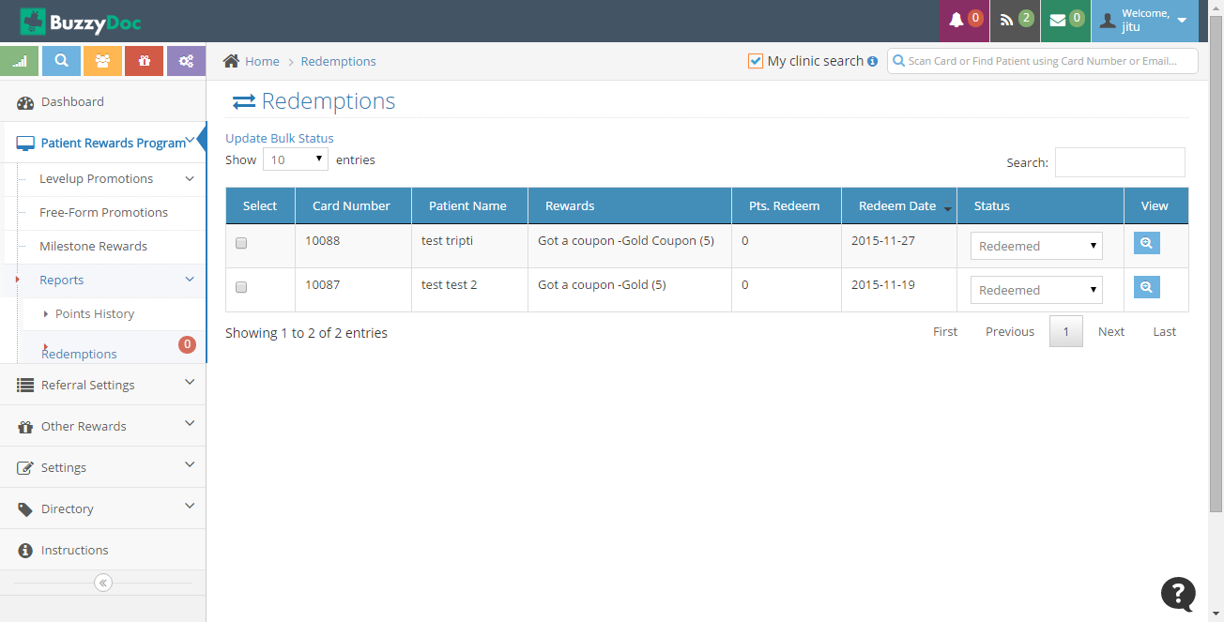

**3. Referral Settings**

Each Time a patient refers the clinic in his/her circle it would be shown under **“Referrals”**. It’s status has to be changed manually if the referral gets completed or gets failed.

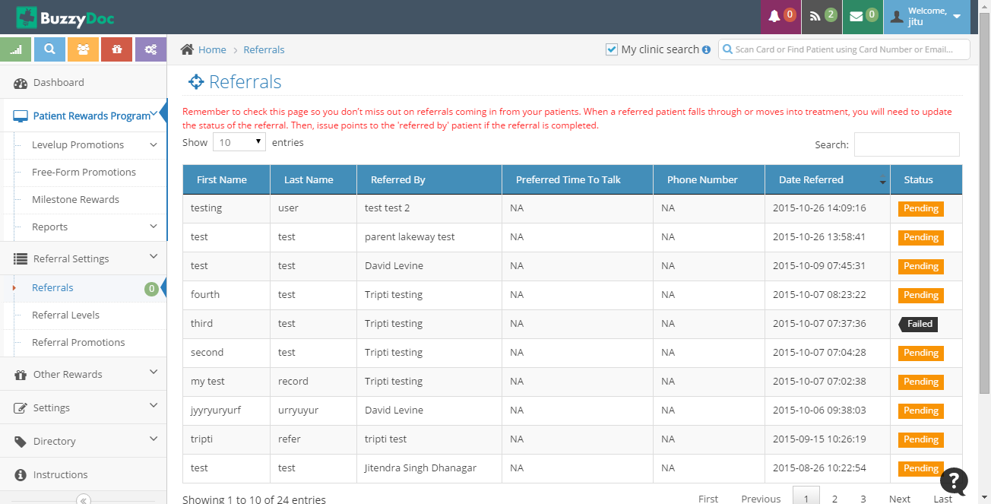

**Referral Levels**

It allows to show the Referral Level and Points corresponding to it. It also allows to add Local Referral points for each level (i.e clinic points)

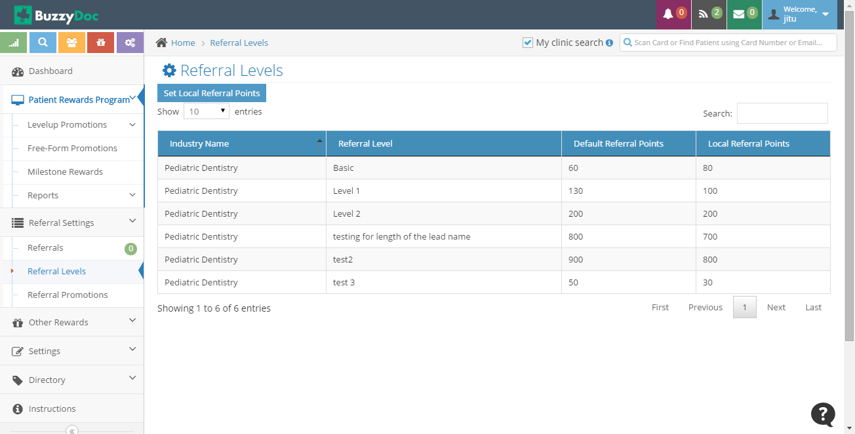

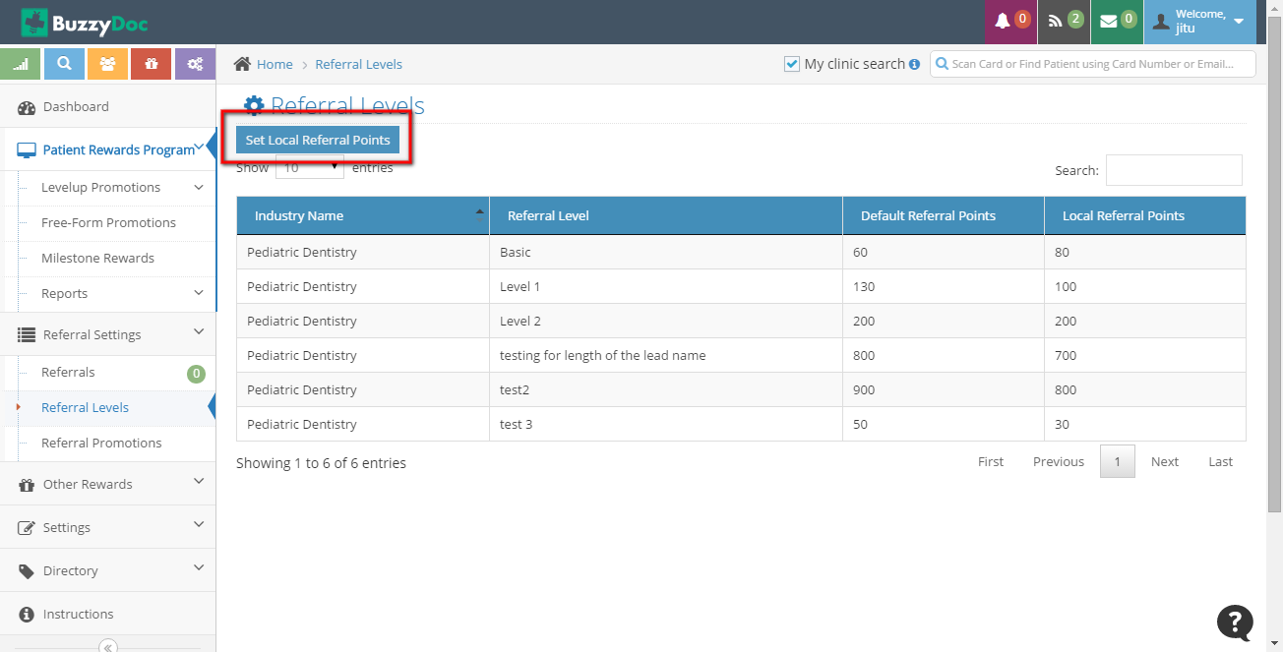



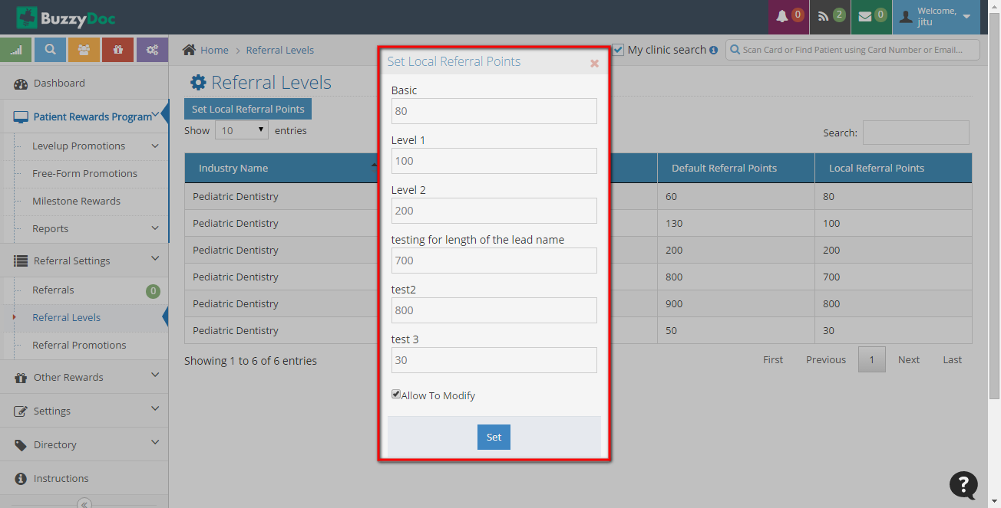

**Referral Promotions**

Referral Promotions are the Promotions sent in an Email on referring Clinic.It allows to send promotions through Email each time clinic is referred annd user becomes it’s patient.

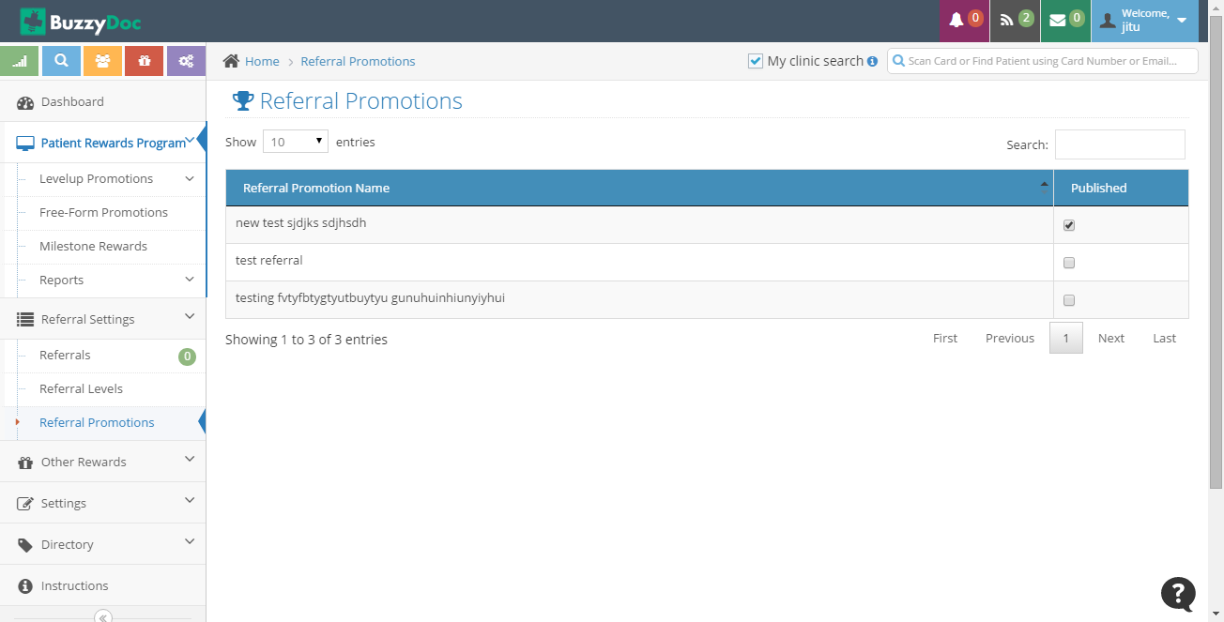

**4. Other Rewards**

Other Rewards allows to Manage Rewards for Milestone Rewards. Rewards added here is shown under Milestone Rewards.

**Manage Other Rewards**

Manage Other Rewards allows to Add, Edit and Delete Product/Service/Coupon. Staff Member can Add Rewards which are given to be Patients on attaining ceratin predefined levels.

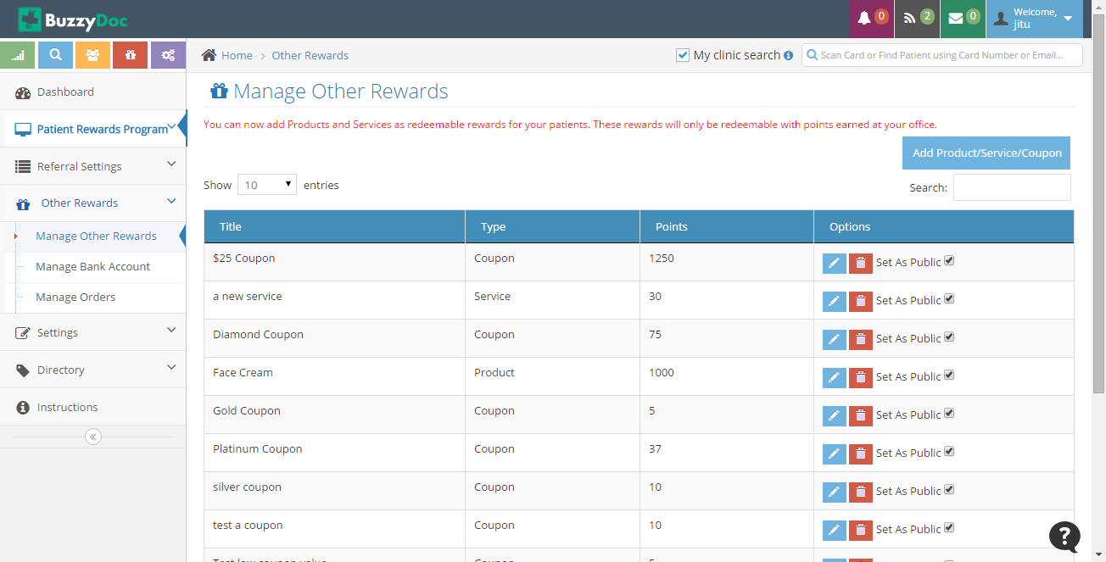

**Add Rewards**

By Clicking “Add Product/Service/Coupon” Staff can add type of reward he wants to.

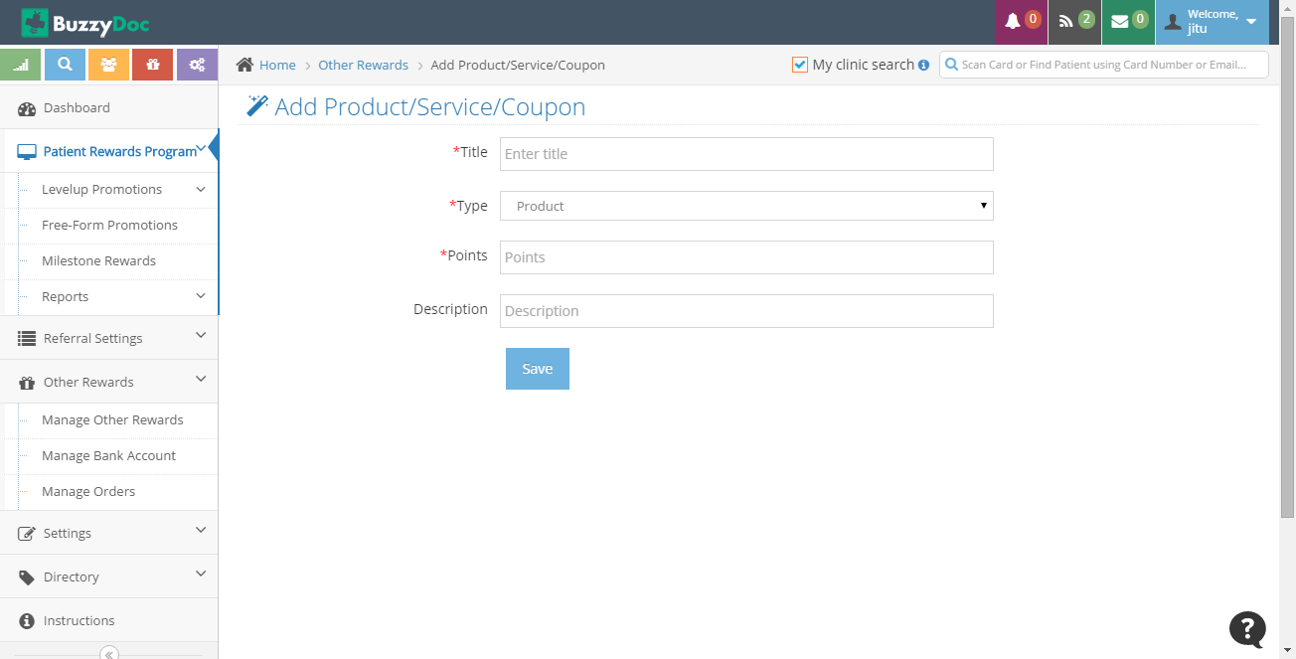

**Title -** It describes the Name of the Reward

**Type -**  It describes Reward is of what type? It allows Staff to select from Product,Coupon and Service

**Points -** It allows Staff to add Points to be awarded against it.

**Description -** It allows to Describe about the Rewards

**Manage Bank Account**

It allows to add Bank Account through which all the Debit and Credit will be done.

**Manage Orders**

It allows to Manage Orders which are redeemed through Patients. Through this each time a Product/Service is Redeemed by the patient, Staff has to manually update the status of the redemption.

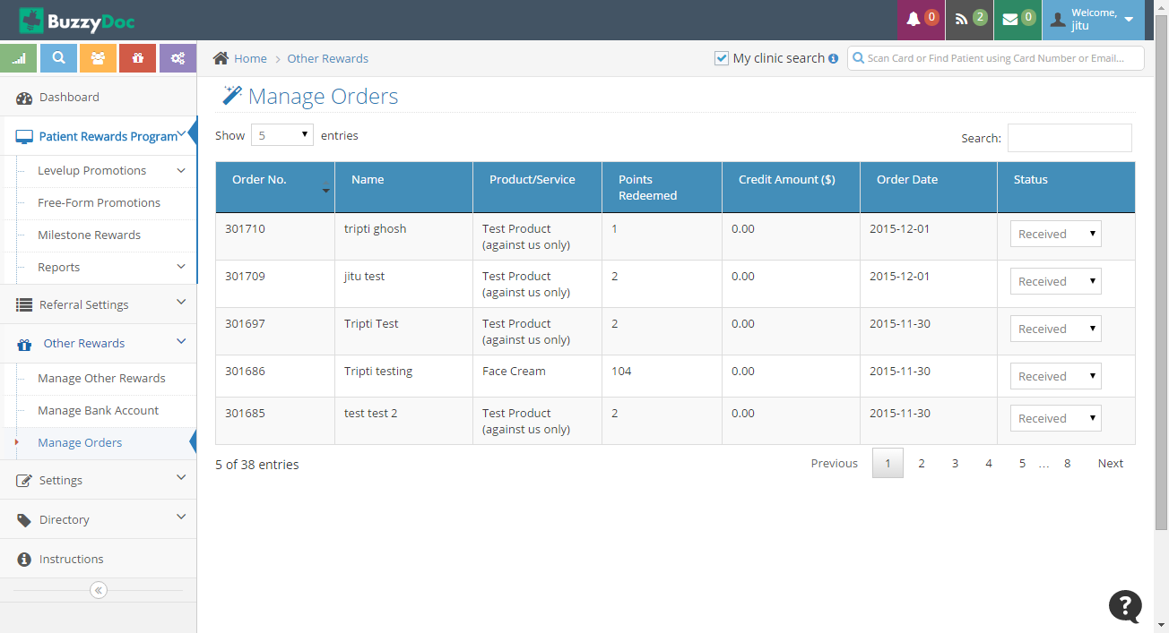

**5. Settings**

This section allows to Add Staff Members,Documents and allows to know Basic Report, Balance Status and Payment Details.

**Staff**

It allows to Add,Edit,Delete and Activate/Inactive the Staff Member.

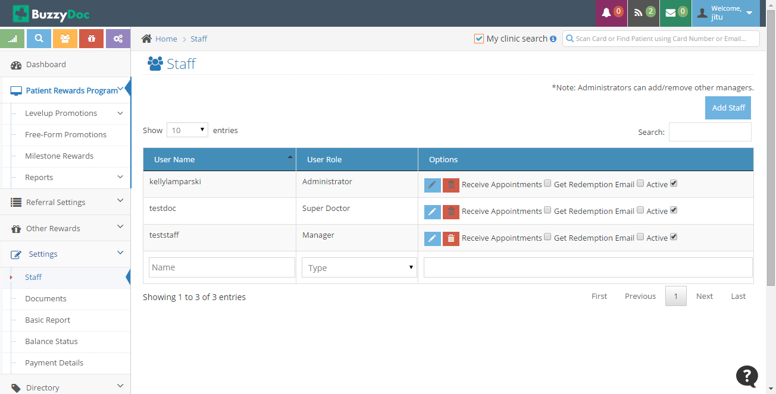

**Documents**

From this section Staff is able to Upload New documents which will be shown on Front End.

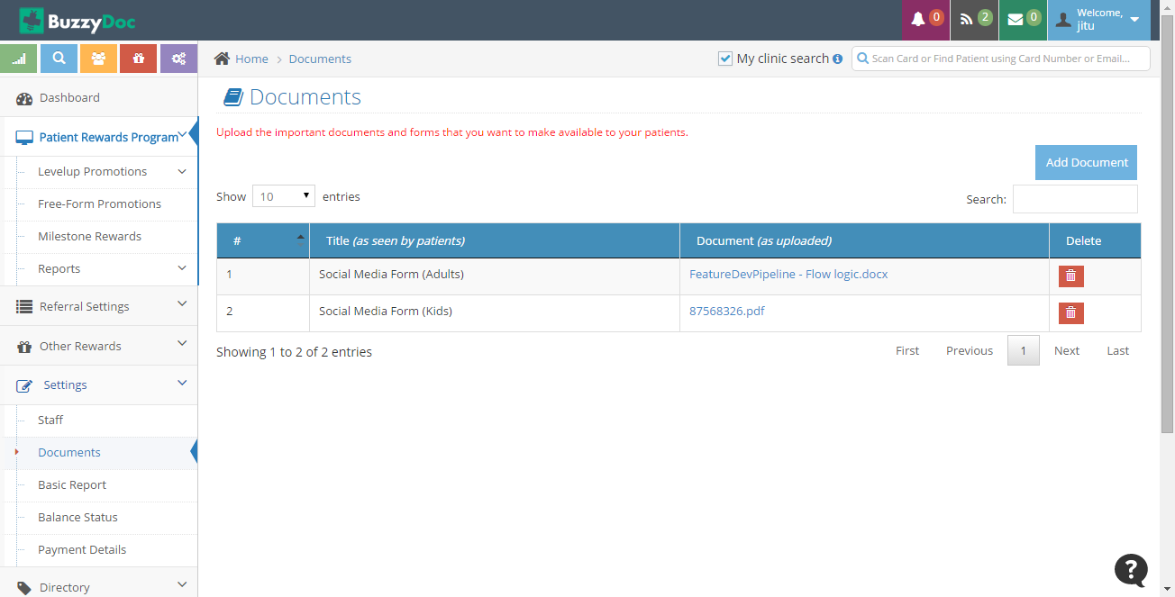

**Basic Report**

It generates the basic report for the clinic. It tells how many point has been awarded ,redeemed etc.

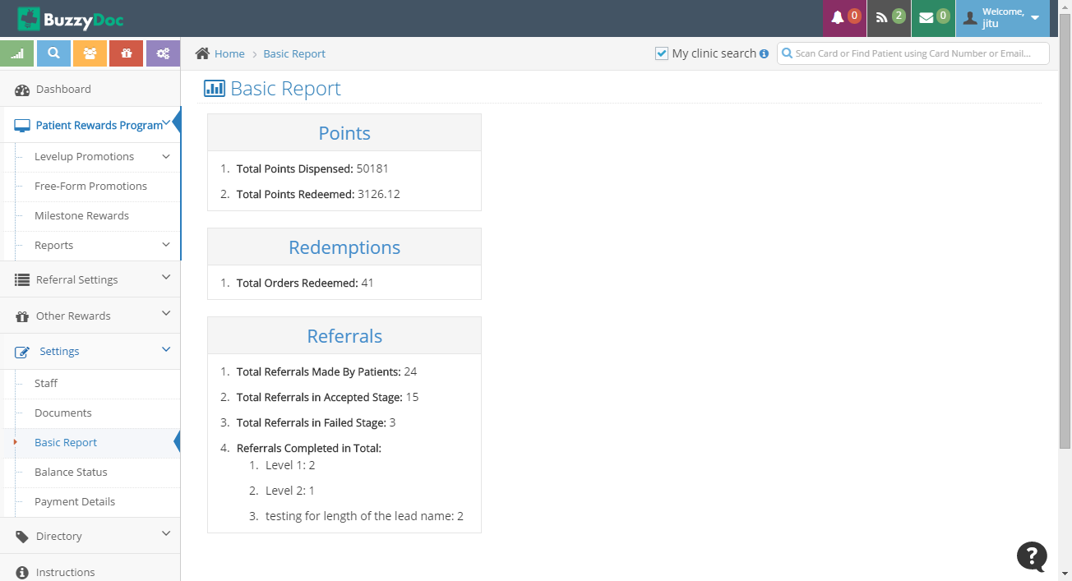

**Balance Status**

It shows the total Balance available of the clinic. It Automatically recharges the account on reaching a threshold point.

**Payment Details**

It allows to add Shipment Address and Payment Method. All the Redemption made by Patients will be delivered to the Shipment Address and all the payments are done through specified details.

**6. Directory**

It describes the Clinic Locations, Doctors available, showcast Doctors Review, Payment History etc.

**Clinic Locations**

It describes all the Locations of the Clinic. It allows to set 1 Prime Location from all the Locations which is shown on front end.

.

**Doctors**

It allows to Add,Edit and Delete the Doctor’s related to the clinic. Only 1 Doctor can be set as Default Doctor out of all the Doctors.

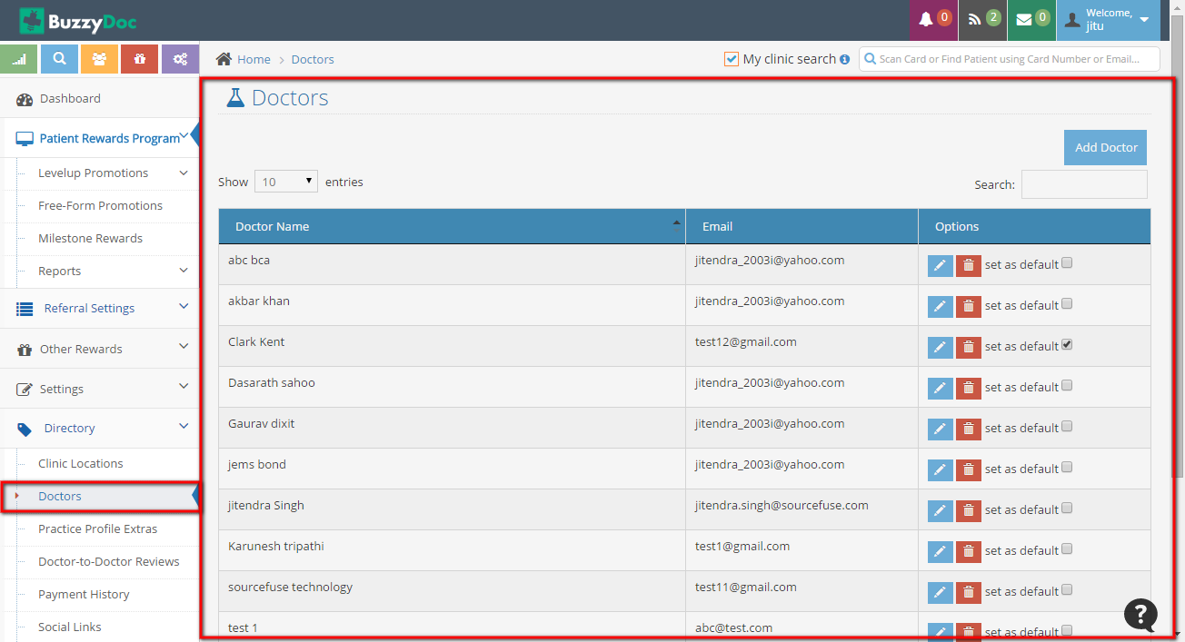

**Practice Profile Extra**

It allows to add Insurance/Procedure/Characteristic which are to be accepted by the clinic.

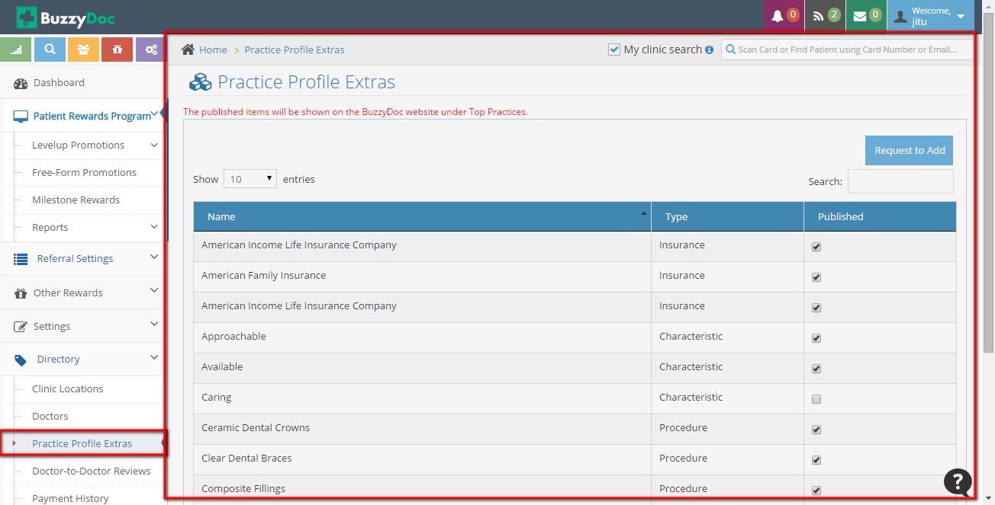

**Doctor to Doctor Review**

From here Doctors are allowed to make Reviews for other Doctors.

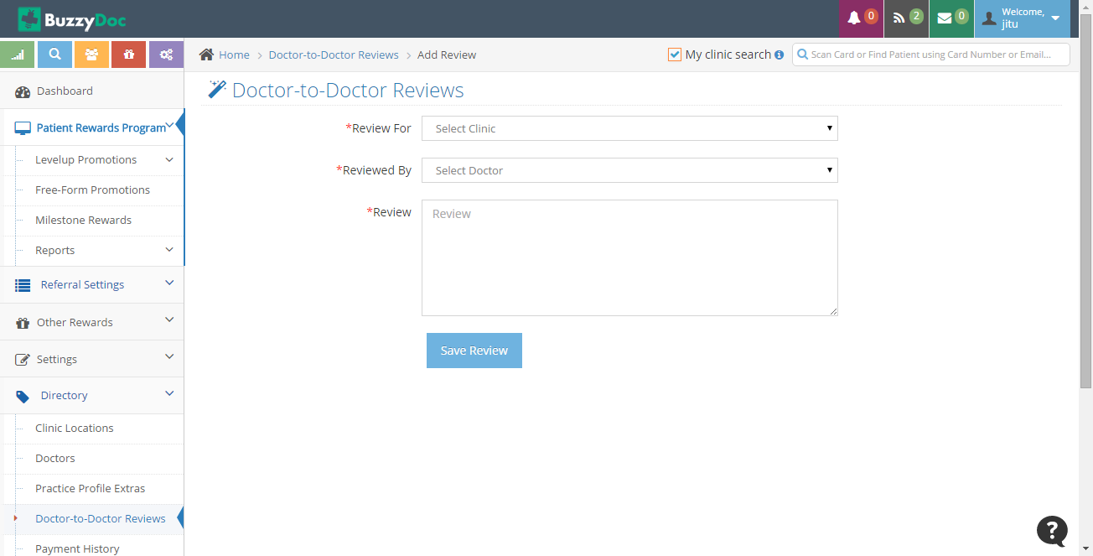

**Payment History**

It tells all the payment made till date.

**Social Links**

It allows to add all Social Links which will be displayed on Front End ie Buzzydoc site.

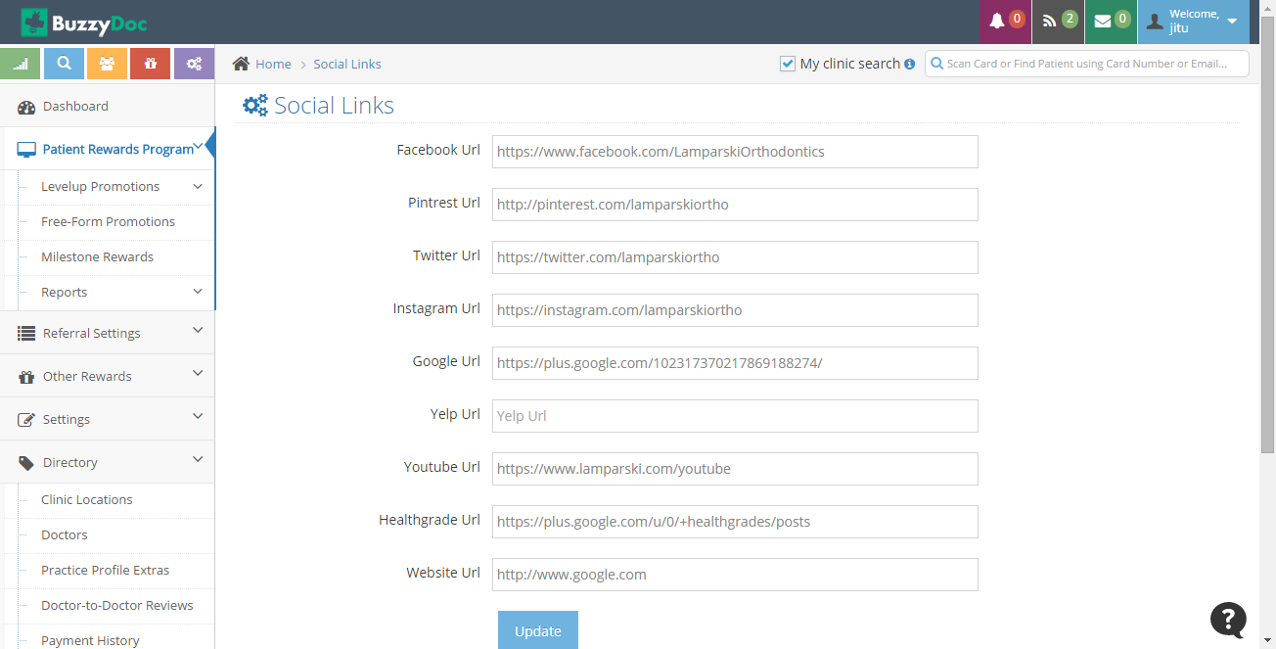

**7. Patient Management**

Staff can search Patients by Card Number,Patient Name or Email from Search Box at top right corner.

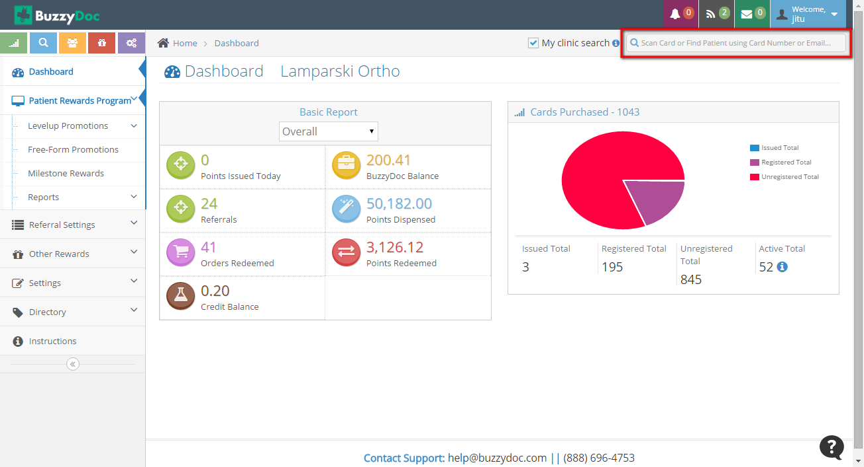

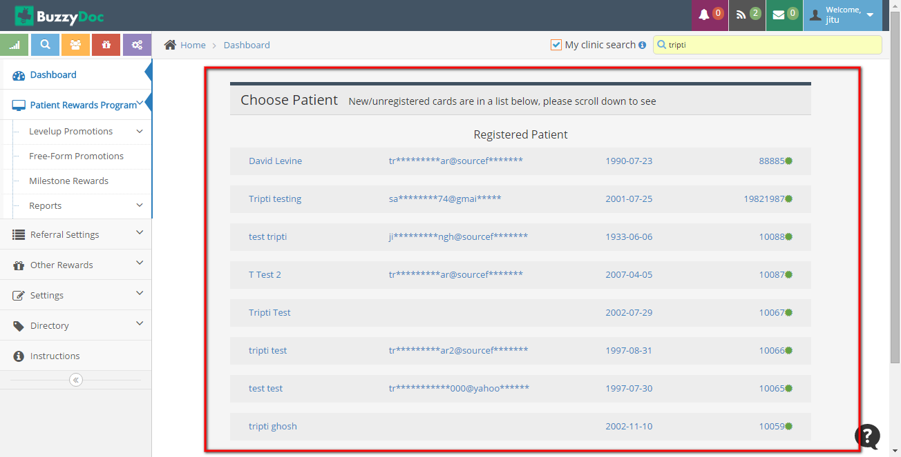

On clicking onto the User details page will be redirected to Patient Management Page

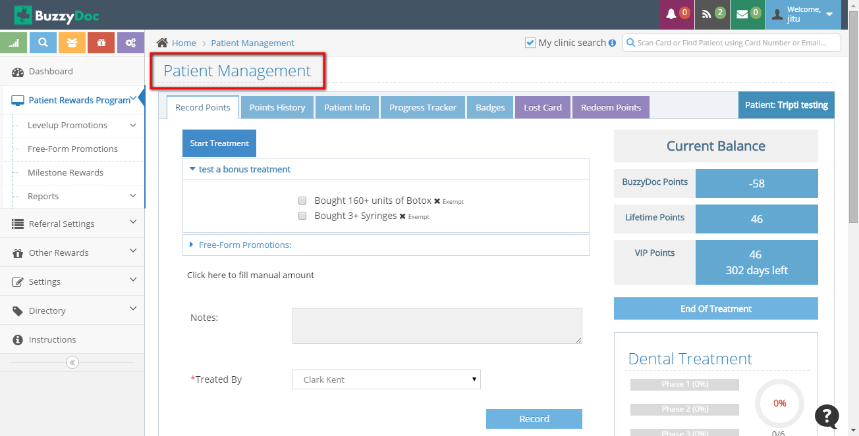

**Record Points**

Record Points allows to Start Treatment and give points to the Patients. Once Treatment is started on every perfect phase points will be given to the Patient pre decided under Level Up Treatment Plan.

Staff can also give extra points through Free Form Promotions.

**Points History**

It describes all the points given to the patient.

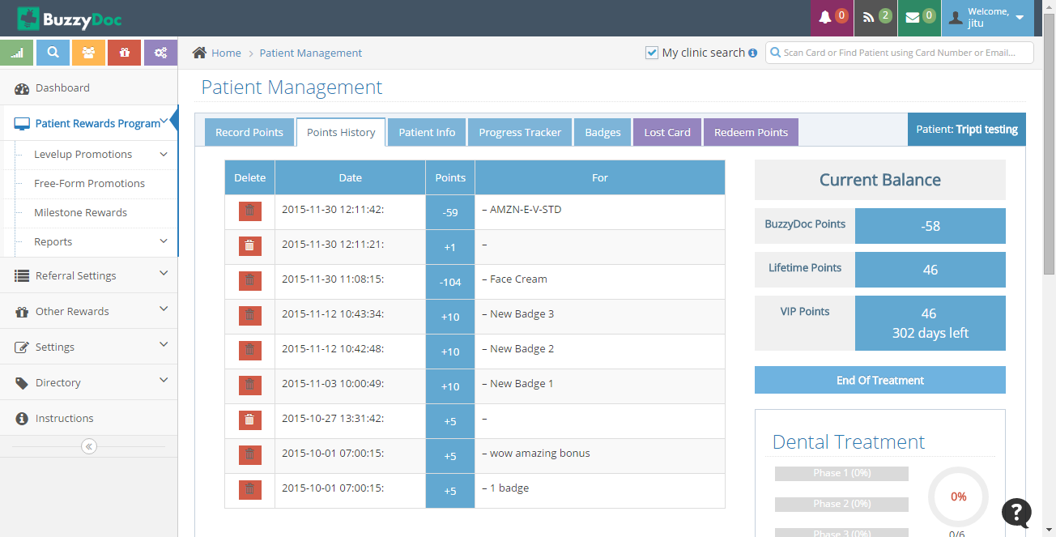

**Patient Info**

It allows to show and edit all the Patient related Information.

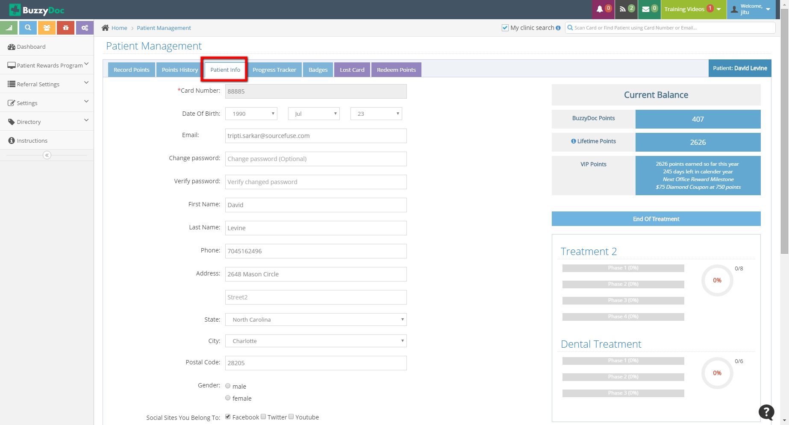

**Progress Tracker**

Progress Tracker module defines how many phases has been completed, out of them how many had been perfect phase, on what all days patient visited the clinic and what’s the Treatment Status.

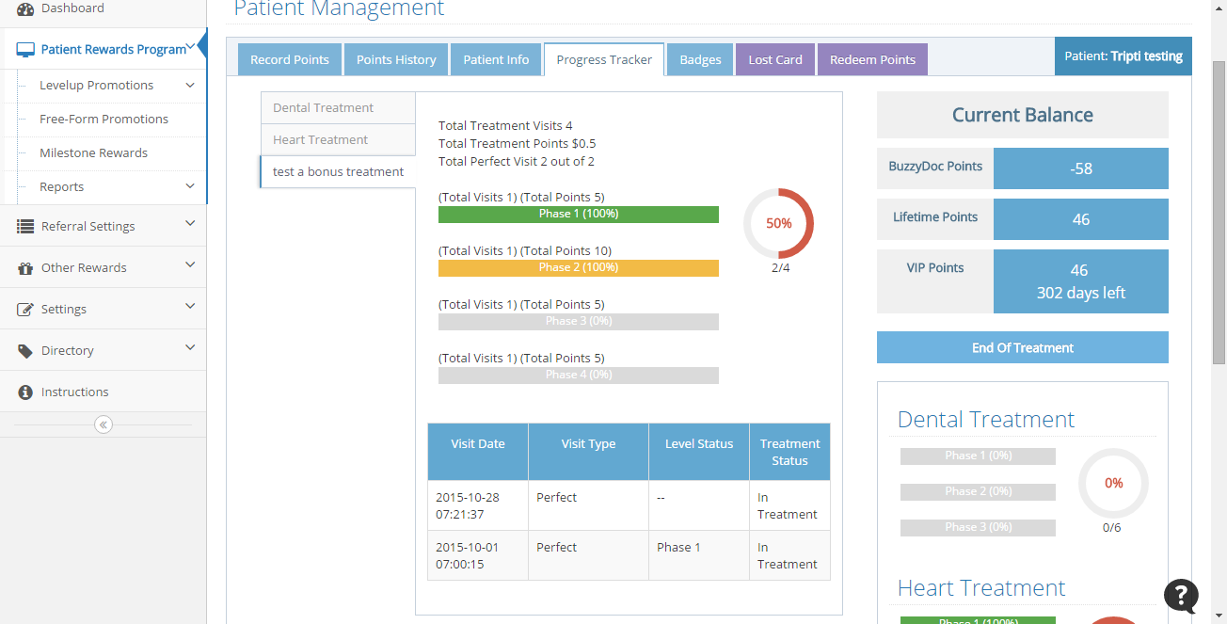

**Badges**

It describes what all Badges have been given to the patient depending on what all levels patients have achieved.

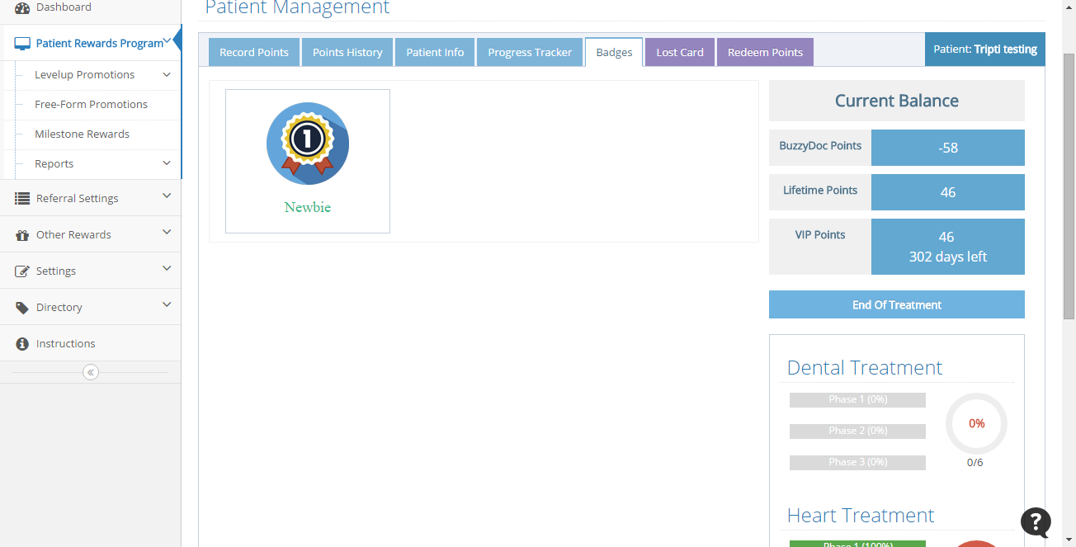

**Lost Card**

It allows to assign new card to the patient in case of lost or tempered card.

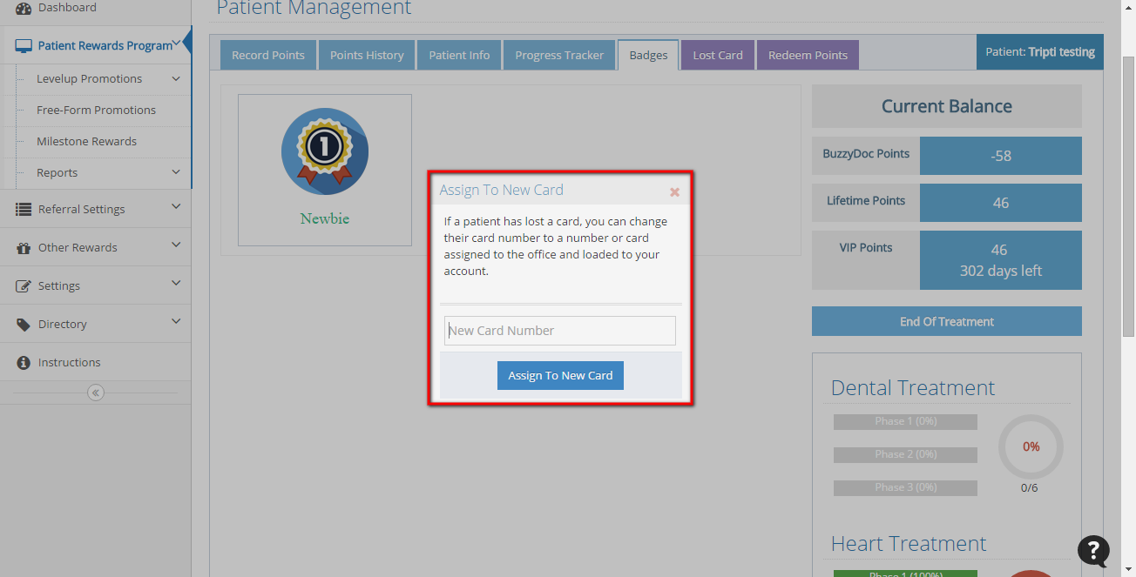

**Redeem Points**

This module allows to Redeem points from the different vendors like Amazon and Tango. If user don’t have the points equivalent to the price of the product in that case also Product can be redeemed by giving cash for the balance.

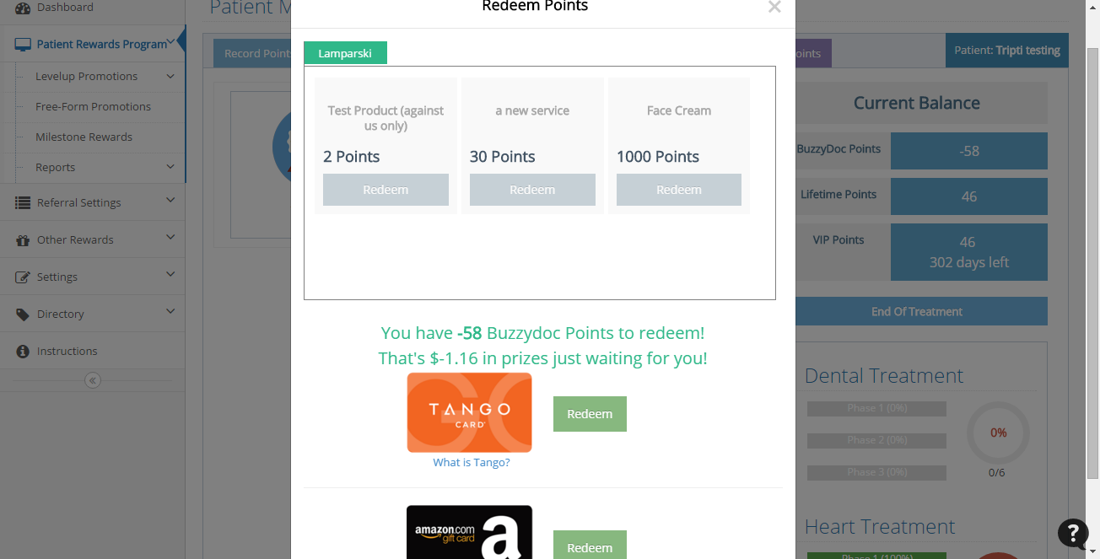

**Current Balance**

It allows to showcase the Balance Summary of the specific patient of which Staff is viewing the profile.



* **BuzzyDoc Points**

Points that are given by BuzzyDoc Clinic to the patient are known as BuzzyDoc Points

* **Lifetime Points**

All the points patients has gathered from BuzzyDoc Clinic since he got enrolled to BuzzyDoc clinic.

* **VIP Points**

Points gathered from BuzzyDoc clinic over the year which would be zeroed out when yearly cron runs and coupon would be sent to user equivalent to the points.